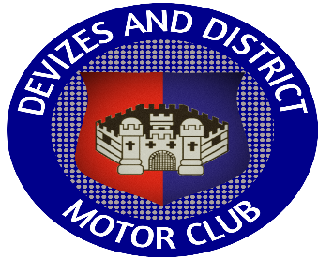
Devizes & District Motor Club
Membership Application Form 2023
I/we wish to apply for membership of Devizes and District Motor Club
Name
Address | Postcode:
Telephone | Home:  Work:  Mobile:
Email
Single £15 [ ]  Joint/Family £20 [ ]  Associate £5 [ ]  (Please make cheques payable to Devizes &District Motor Club)  Application can also be made on the website:  www.ddmc.co.uk |  | Membership Secretary:  Ian Silcocks  Email: membership@ddmc.co.uk

Data Protection: Devizes & District Motor Club is the data controller for the purpose of GDPR and the Data Protection Act 2018.
Member’s personal data is kept in a secure manner solely for administration purposes relating to the operation of Devizes & District Motor Club and Motorsport UK and will not be disclosed to a third party without permission.
Devizes & District Motor Club uses email to communicate with individual members over the age of 18 to provide information on Club activities and events. If you do not wish to be contacted by email please tick this box

When you are issued with a Club Membership card you will also be asked to confirm receipt of a paper copy of the Devizes & District Motor Club Privacy Notice and Safeguarding Policy.

I/we agree to be bound by the rules and regulations of Devizes & District Motor Club and Motorsport UK | Signature of applicant:

